Manual Guide
how to edit the slider on your website

S338225
The source of library, used in the slider

The slider uses a compressed 1.8.3 version of the jQuery library and special libraries for slider – jQuery.easing (1.3 version) and a minified version of jQuery.iosslider.min.js. Apart of that there is a script called slider.js which is used to change settings such as autoSlide and autoSlideTimer.

The 1.8.3 version of jQuery can be downloaded at https://code.jquery.com/jquery/ and jQuery.easing and jQuery.iosslider libraries are available at GitHub - https://github.com/gdsmith/jquery.easing and https://github.com/iosscripts/iosslider.

Links to all these libraries should be added to html file inside <head> teg.

Apart of that the html file should have a link to a JS file with this code inside:

$(document).ready(function() {

$('.iosSlider').iosSlider({
desktopClickDrag: true,
snapToChildren: true,
navSlideSelector: '.sliderContainer .slideSelectors .item',
onSlideChange: slideChange,
scrollbar: false,
autoSlide: true,
autoSlideTimer: 3300,
infiniteSlider: true
});

});

function slideChange(args) {

$('.sliderContainer .slideSelectors .item').removeClass('selected');
$('.sliderContainer .slideSelectors .item:eq(' + (args.currentSlideNumber - 1) + ')').addClass('selected');

}

All these libraries and JS file should be placed in JS folder. Also, a CSS and IMAGES folders must be created. In CSS folder there is a style file where we can change settings such as resolution of images and background image. The folder IMAGES contain all images that should be displayed on the slider and a background image picture.

How to add/remove images to/from the slider

1. The number of images that you want to be on the slider must coincide with the number of DIVs with class “inner” inside onather Div with class “item itemNumber”.

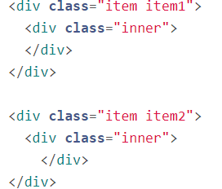

2. To create the same amount of icons at the bottom of the slider, we need to create as many DIVs with class “item” inside of the DIV with class “slideSelectors” as we have images. The first DIV with class “item” also should have class “selected”
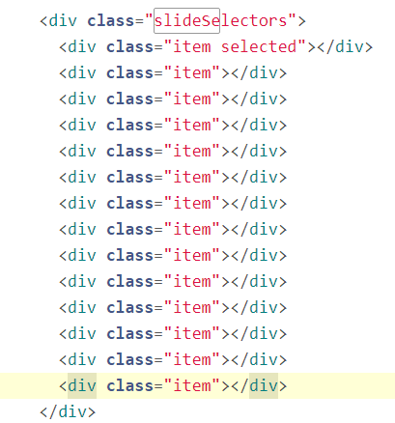

3. In the CSS file we need to link images from the IMAGES folder to the DIVs with class “item itemNumber”

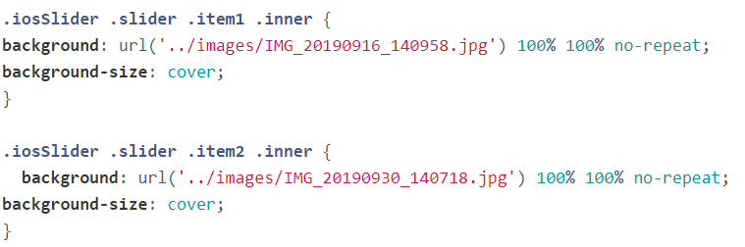

Images sides and resolution of images for this slider

To comply with assessment the side ratio of the images should be 1:0.3 because images will be placed in a DIV with 1000px width and 300px height. So, if images with another ratio will be placed in the slider, they might be shown wrongly. All images should be placed in the IMAGES folder. Also, in the IMAGES folder should be placed a background image (container-bg.jpg in this case).

All images must be in JPG or in JPEG or in PNG format only.

To adopt the slider to different ratio images the .iosSlider selector in the CSS file must be removed

In this case the height of images on the slider will remain 300px but the width will be adopted automatically.

Change the slider settings

The slider settings (such as auto sliding and time of sliding) can be changed. To do it you need to edit slider.js file in JS folder. To change the time of image displaying you need to modify the autoSlideTimer property and to switch off auto sliding you need to put false to autoSlide operator
